**FINAL MAJOR PROJECT BY PRAJWAL T S-**

**AIM:**

To make a basic Online Booking system that can book seats, appointments and tickets etc.

**CODE:**

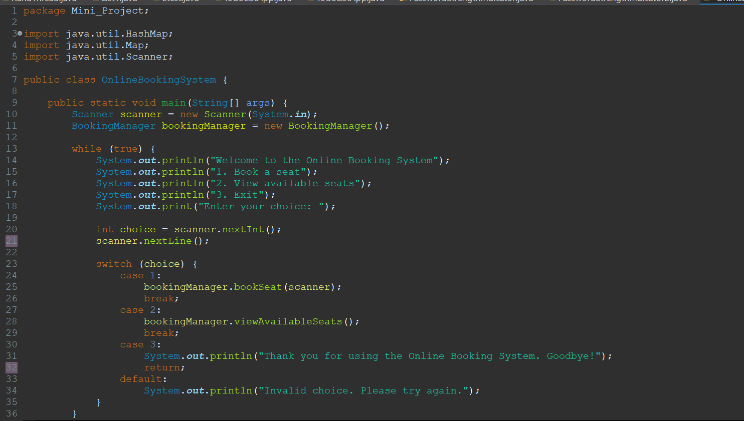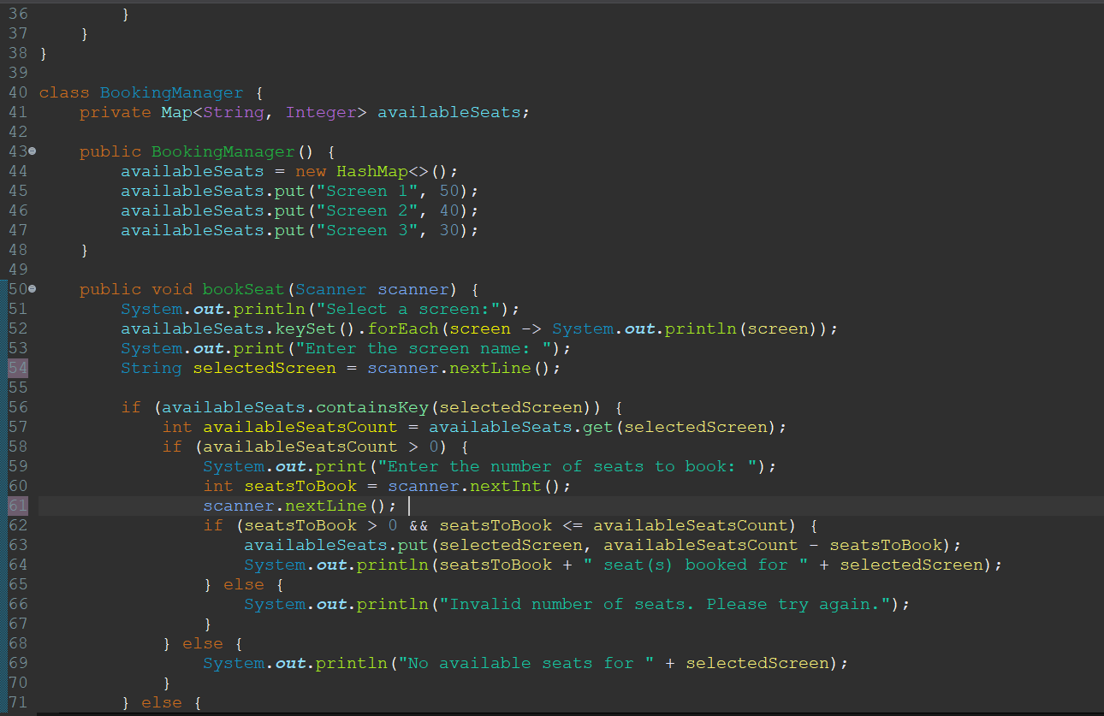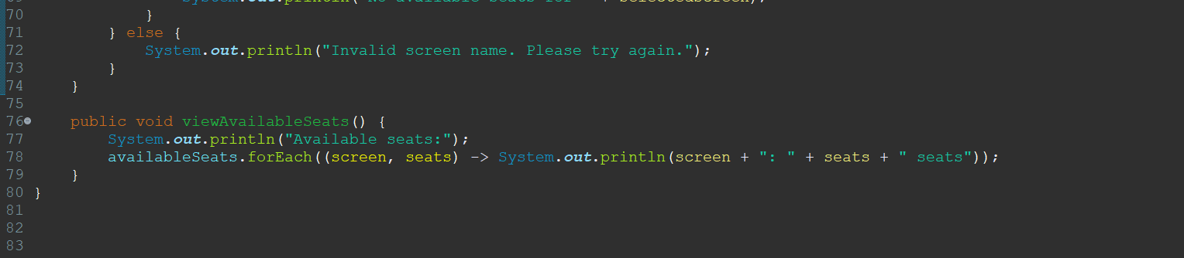

**OUTPUT:**

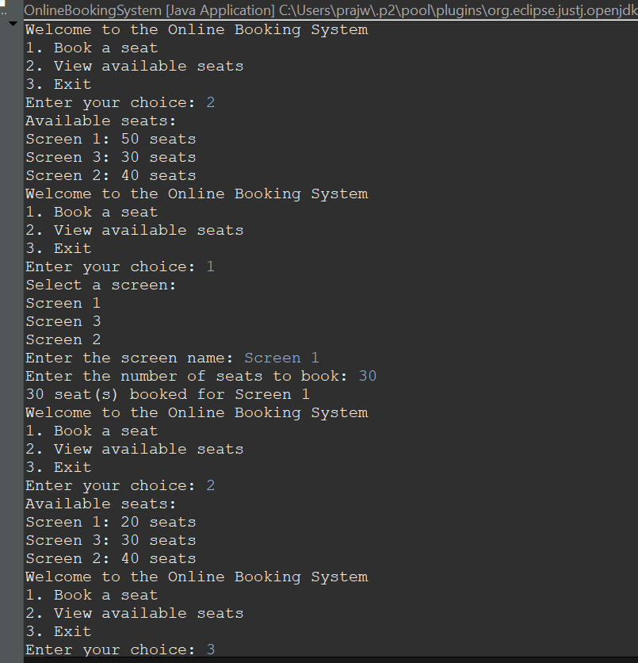

**ABOUT THE CODE:**

This code provides a basic interface for booking seats in different screens. It maintains the number of available seats for each screen and allows users to book seats. You can extend and customize this code to fit the requirements of your specific online booking system.

**WORKING:**

1. Initialization: The code begins by initializing a map called available seats. This map stores the available seats for different screens or sections in a venue.

2. Main Menu: The program presents a main menu to the user, which includes three options:

- Book a seat.

- View available seats.

- Exit the program.

3. Book a Seat:

- When the user selects the "Book a seat" option, they are prompted to choose a screen or section.

- The code validates the user's input to ensure it corresponds to a valid screen.

- If the selected screen is valid, the program then checks the availability of seats in that screen.

- The user is asked to input the number of seats they want to book.

- If the requested number of seats is available, the booking is processed, and the availability is updated. If not, an error message is displayed.

4. View Available Seats:

-Choosing the "View available seats" option displays the current seat availability for each screen.

5. Exit:

- The user can choose the "Exit" option to terminate the program.

6. Loop:

- The program runs in a loop, allowing the user to perform multiple actions without exiting the program until they choose to do so.

**How does the code work?**

- The code uses a map to store and manage available seats for different screens.

- Users can book seats in screens and check seat availability.

- It provides a simple command-line interface for interaction.

- However, it's a basic example and does not include advanced features such as error handling, data persistence, or a graphical user interface.

- The code provides a starting point for more complex online booking systems and can be customized and extended as needed.

**ADVANTAGES AND DISADVANTAGES :**

**ADVANTAGES:**

1. Convenience: Users can book services or purchase tickets from the comfort of their homes, eliminating the need to visit physical locations or make phone calls.

2. 24/7 Availability: Online booking systems operate around the clock, allowing users to make reservations at any time, even outside of business hours.

3. Reduced Overhead Costs: Businesses can save money by automating the booking process, reducing the need for staff to handle bookings manually.

4. Increased Efficiency: Online booking systems can handle multiple bookings simultaneously, reducing wait times for customers and improving overall efficiency.

5. Data Insights: These systems provide valuable data and analytics that can help businesses better understand customer behavior and preferences, enabling them to make data-driven decisions.

**DISADVANTAGES:**

1. Technical Issues: Online booking systems can encounter technical glitches, leading to booking errors and frustrating user experiences.

2. Security Concerns: There is a risk of data breaches and privacy issues when handling sensitive customer information online.

3. Lack of Personal Interaction: Some users may prefer personal interaction when making bookings, which is lost in an online system.

4. Limited Customization: Online booking systems may lack the flexibility to accommodate complex or customized booking requirements for some businesses.

5. Dependency on Internet: Both customers and businesses are reliant on a stable internet connection to use online booking systems, which can be a limitation in some areas.

**FUTURE SCOPE:**

The future scope of online booking systems is quite promising, as technology continues to advance and businesses across various industries recognize the value of providing convenient and efficient booking options for their customers. Here are some aspects of the future scope of online booking systems:  
  
1. Integration with Emerging Technologies: Online booking systems will likely integrate with emerging technologies like artificial intelligence (AI), machine learning, and chatbots to offer more personalized and interactive booking experiences. AI can help in predicting customer preferences and streamlining the booking process.  
  
2. Mobile Optimization: As mobile device usage continues to grow, optimizing online booking systems for mobile platforms will be crucial. This includes developing user-friendly mobile apps and responsive web interfaces.  
  
3. Cross-Industry Applications: Online booking systems will expand their presence into various industries beyond travel and hospitality. For example, healthcare, fitness, and education sectors are increasingly adopting online booking systems for appointments and classes.  
  
4. Enhanced User Experience: Future online booking systems will focus on enhancing the user experience with features such as real-time availability, instant confirmations, and interactive seat selection for events or transportation.  
  
5. Sustainability: There will be a growing emphasis on sustainability, with eco-friendly options integrated into booking systems, such as choosing environmentally responsible accommodations, transportation, or events.  
  
6. Blockchain Integration: Blockchain technology could be used to enhance security and transparency in online bookings. It can help prevent fraud, reduce chargebacks, and streamline payments.  
  
7. Global Expansion: Online booking systems will continue to expand globally, connecting customers and service providers from different regions, languages, and cultures.  
  
8. Analytics and Data Insights: Advanced analytics and data insights will play a crucial role in helping businesses make informed decisions, from pricing optimization to marketing strategies.  
  
9. Virtual Reality (VR) and Augmented Reality (AR): VR and AR can be integrated into booking systems to provide virtual tours and previews of accommodations, venues, or travel destinations.  
  
10. Voice-Activated Booking: As voice-activated devices become more prevalent, online booking systems may integrate with voice assistants to allow users to make bookings using voice commands.

Overall, the future of online booking systems is expected to revolve around increased personalization, convenience, and the integration of innovative technologies to meet the evolving needs and expectations of users and businesses.